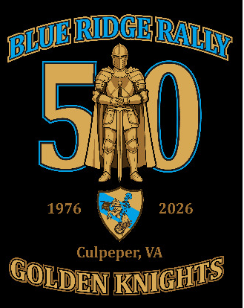
September 4 – September 7, 2026

HOST HOTEL
Please call the hotel directly at (540) 825-1253 and press “0” to reach the front desk in order to reserve or confirm an existing reservation. Tell them you are with the Blue Knights Rally. If you don’t press “0” you will not get the Culpeper Hotel and will be told they are sold out.

Baymont/Days Inn, Culpeper
791B Madison Road
Culpeper, VA, 22701
RATE: $95/night

RALLY REGISTRATION
Adults: $110, Couples $220, Child (7-14 years old) $70 - Price includes sit down meals Friday & Saturday nights; midday meal Sunday; hospitality room and beverage trailer access; an event memento; and all of the fraternal camaraderie you can handle for a weekend. Please put Chapter name/number in the remarks block during check out. Register at : https://blue-knights-virginia-ii.square.site/

FRIDAY, September 4, 2026
Hospitality room with lots of beverages and snacks, Beer Trailer, Soak up rays by the pool, Dinner, 50/50 raffle . . . Reunite with old friends and make new ones!

SATURDAY, September 5,2026
Hospitality room with lots of beverages and snacks, Beer Trailer, soak up more rays by the pool, RIDES*, explore the history rich area, Banquet Dinner, 50/50 raffle, Virginia LEOSA Qualification (Range pending).

* We will offer a couple of guided rides through the Shenandoah Mountains, which will be announced at dinner on Friday.

SUNDAY, September 6,2026
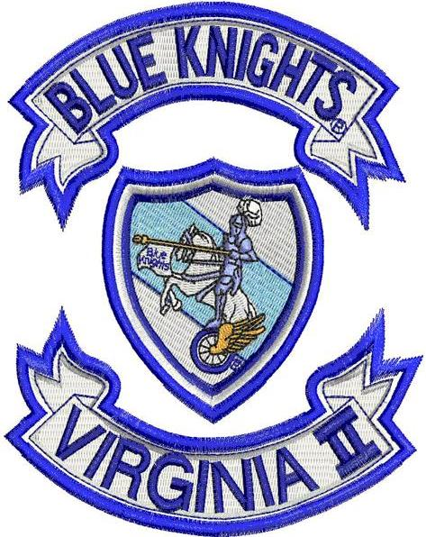
MDC Fall Conference Meeting at 0930
Lunch & Stop the Bleed Training

MONDAY, September 7, 2026
Ride with Pride - Safe travels back home!
